Mummy Game

Game Functionality

Contents

Overview 2

Behavior 2

Splash Screen 3

Play Area 4

Question with Options 4

Timer 4

Compass 4

MAGIC WAND 5

Ask the Mummy 5

Feedback 5

Final Screen 6

Review and Analyze Module 7

QA Mode 8

# Overview

Whole game reflected with the millionaire game. This game starts with the **splash** screen. On click start button, game will proceed to the **play area** where 15 questions are rolling in the same behavior just graphics will change after each stage (five questions). If 15 questions answered correctlythen **Final screen** will showing up with the **play again** and **Review & Analyze** buttons.

Behavior

First - question will appear with four answer choices (only single correct).

On click **correct choice** - screen will proceed to the feedback screen.

On click **incorrect choice** - screen will proceed according to the condition.

Condition:

If (any **life-line** remains then popup will showing up and indicate remaining **life-lines)**

Else (game over and popup will showing with the play again button)

**Timer** (optional) – each question has 30 sec for answer. After 30 sec time up screen will showing up with the **play again** button.

# Splash Screen

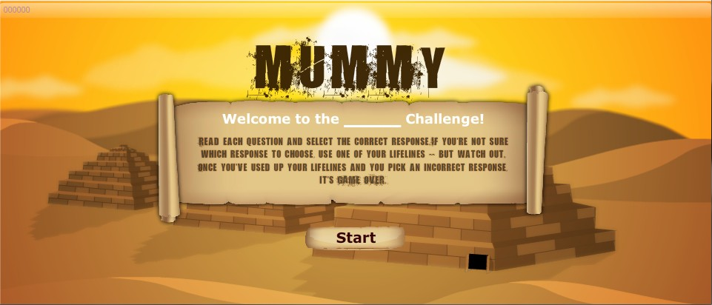

This is the first screen which we call splash screen there are two things which can be fully customized by author.

1. The Content ID at top left (00000) corner of the screen
2. Sub title in white color

# Play Area

Question with Options

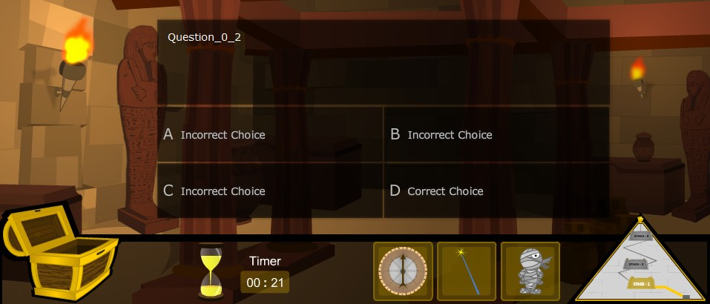

This is the main screen or actual Game Play which appear when you click start button in which as in screen shot.

Display 1 question with four options , among which 1 is correct and others are incorrect along with optional timer and map of stage you are currently playing on the bottom-right Corner this screen also shows the three life lines namely , **Timer** , **Compass** and **Magic wand** , they are individually discussed below.

Feedback

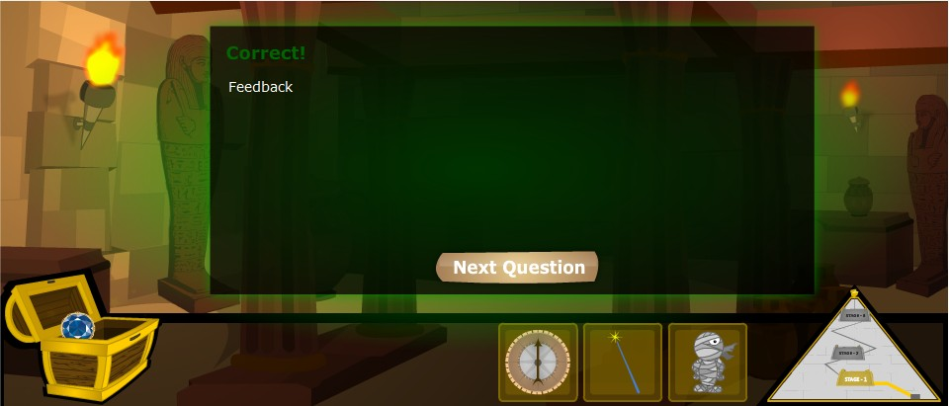

Feedback is the screen which will let the viewer know whether the option selected by him/her is correct or incorrect, in addition to that user can click button “Next Question” to move forward.

Timer

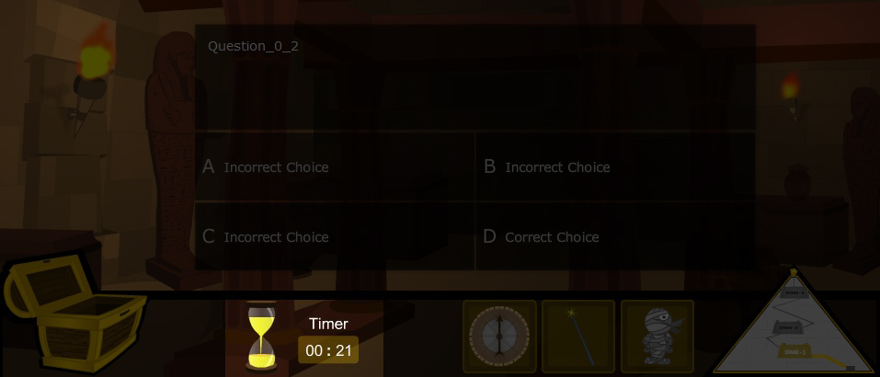

This timer function can be enabled or disabled by author.

# Life Lines

Compass

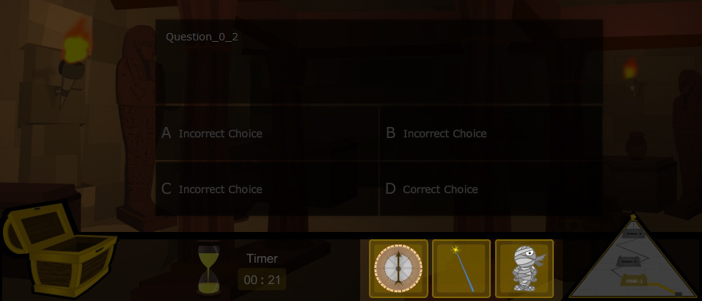

This life line is termed as “Compass”: This works same like “Ask from audience” in trendy “Who wants to be millionaire “game its functions Is very simple and obvious just to guess the probability of an answer being Correct or incorrect in terms of Percentage

MAGIC WAND



Here comes the traditional “Fifty fifty” life line which is named in this game as “Magic Wand”, actions are simplest eliminates two incorrect options with sleek and magical effect leaving a correct and incorrect option to judge from.

Ask the Mummy



Just like Phone a Friend this life line which we call. “Ask the mummy” and it will tell the percentage for an answer being true.

# Final Screen

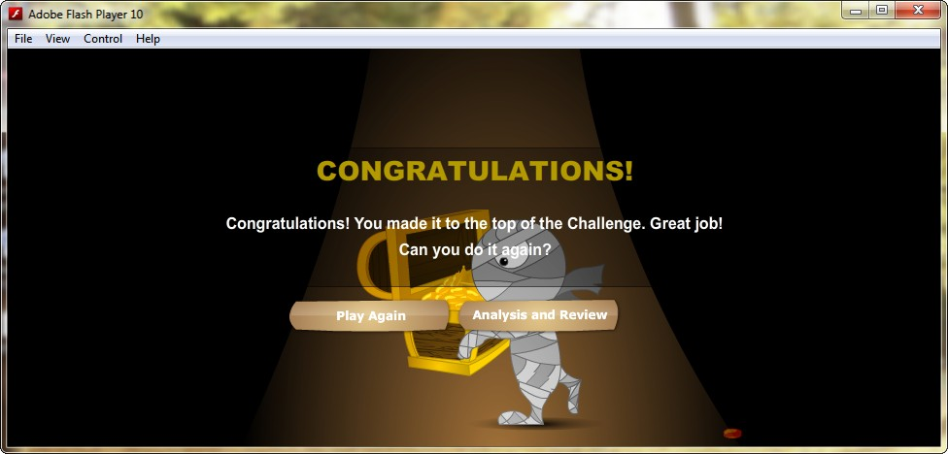

Once you crossed all the 3 levels answering all questions correctly this will be the reward in form of treasure box.

Waiting for you at the end of game and a greeting message of Congratulations will also appear.

Here user is being provided with two buttons.

1. **Play Again:** as the name shows, if user wants to start off again click on this button.
2. **Analyze and Review:** in short answer sheet for comparing question, more details are provided in dedicated section below please refer to that.

# Review and Analyze Module

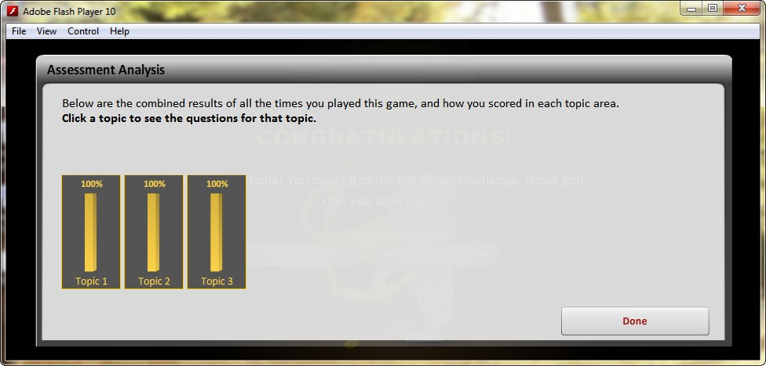

As discussed earlier after clicking the “Analyze and Review button this screen will appear which tells the user that what actually he/she lacks in giving answer. How many options he/she selected were right or wrong, in terms of percentage?

This Section comes with two headings

1. Review
2. Analyze
3. **Review:**

Review mode let you edit the answers by putting different options for same question just to check if you have completed the game successfully but most of your answers were. RIGHT GUESS so this is the section to test your intelligence even after the game is finished, here you can edit and save the answers again.

1. **Analyze**

In this subsection you will be comparing the answers viewer just inserted through review mode.

This will analyze that what percent of answers are right or wrong,

**PS:** These two subsections build a strong. Check and Balance module which we collectively call “Review and Analyze”.

# QA Mode

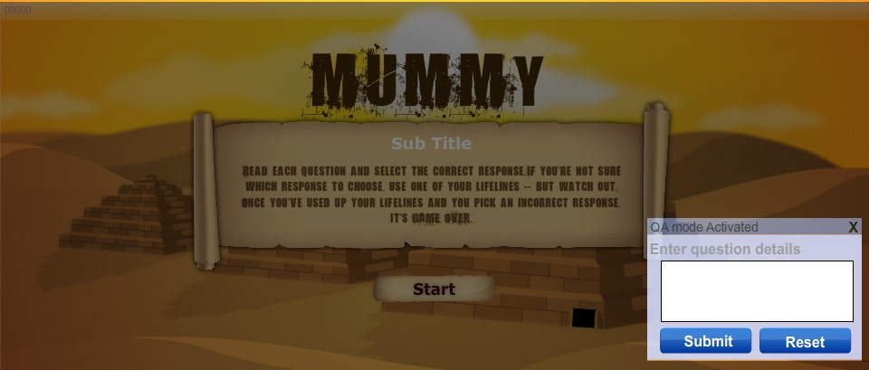

This Special Mode is integrated for authors/production QA dept who let them check the Next questions without the limitation of giving correct answers so that they trace typo mistakes and fix them or to insert specific questions in different slots along with shuffling of the content.